**Library System Management API Documentation**

### Overview

The Library System Management API provides endpoints to manage borrowers and books in a library system. It allows users to register new borrowers, add new books to the library, borrow books on behalf of borrowers, and more.

### Base URL

<http://localhost:8080/book/getAllBooks>\

### Authentication

Authentication is not required for accessing the endpoints.

### Endpoints

#### **1. Add Book**

* **Method**: POST
* **URL**: **/books**
* **Description**: Adds a new book to the library.
* **Request Body**:

{

"isbn": "978-3-16-148410-0",

"title": "Book Title",

"author": "Author Name"

}

**Response**:

* Status: 201 Created
* Body:
  + {
  + "id": 1,
  + "isbn": "978-3-16-148410-0",
  + "title": "Book Title",
  + "author": "Author Name"

}

#### **2. Borrow Book**

* **Method**: POST
* **URL**: **/borrowers/{borrowerId}/borrow/{bookId}**
* **Description**: Allows a borrower to borrow a book from the library.
* **Path Parameters**:
  + **{borrowerId}**: ID of the borrower.
  + **{bookId}**: ID of the book to borrow.
* **Response**:
  + Status: 200 OK
  + Body:
  + {
  + "message": "Book successfully borrowed"

}

### Error Handling

* If a request fails due to validation errors or any other issue, an appropriate error response with the corresponding HTTP status code and message will be returned.

### Usage Examples

#### **1. Add Book**

curl -X POST \ http://localhost:8080/books/addBook \

-H 'Content-Type: application/json' \

-d '{

"isbn": "978-3-16-148410-0",

"title": "Book Title",

"author": "Author Name"

}'

Through Postman:-

Post: <http://localhost:8080/book/addBook>

Json sample:

{

    "isbn": "978-3-16-148411-0",

    "title": "C++ Book",

    "author": "Denis Author"

}

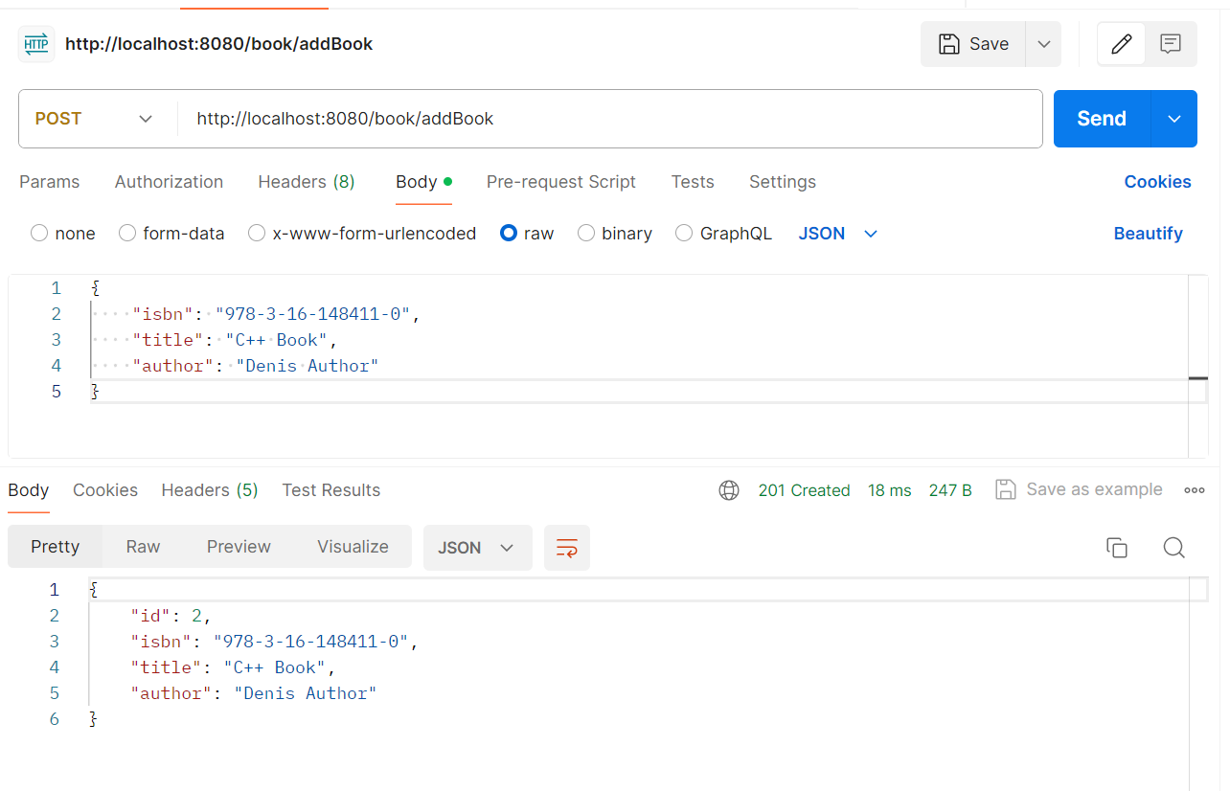

GET API <http://localhost:8080/book/getAllBooks>

